**Examination System Sql Server Documentation**

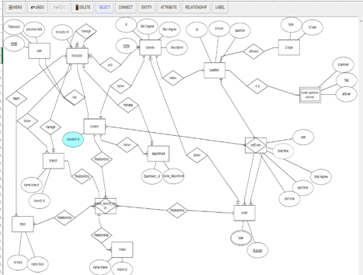

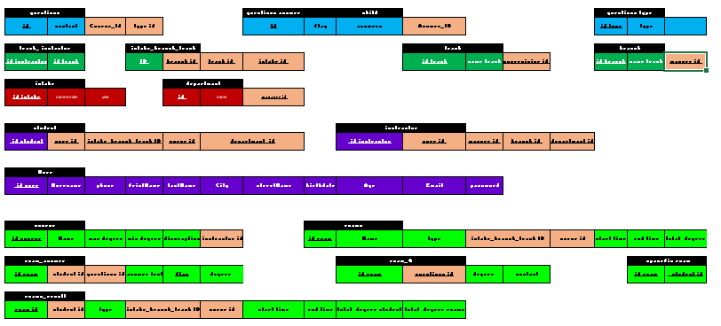

**DATA BASE diagram**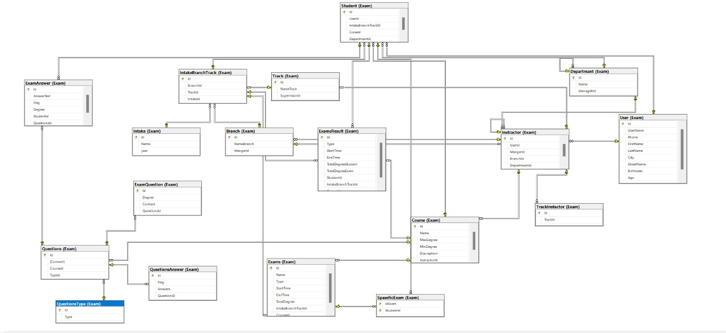

**Examination System Sql Server Documentation**

***Examination System***

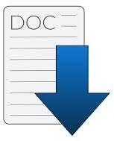

**Team Members:**

***1-Hesham Mohamed***

***2-Nader Mohamed***

***3-Ayman Mohamed***

**Mdf and ndf and logfile.**

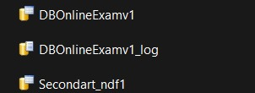

**Tables:**

** [*Exam].[Branch]***

*** [Exam].[Course]***

*** [Exam].[Departmant]***

*** [Exam].[ExamAnswer]***

*** [Exam].[ExamQuestion]***

*** [Exam].[ExamsResult]***

*** [Exam].[Instractor]***

*** [Exam].[Intake]***

*** [Exam].[IntakeBranchTrack]***

*** [Exam].[Questions]***

*** [Exam].[QuestionsAnswer]***

*** [Exam].[QuestionsType]***

*** [Exam].[SpaseficExam]***

*** [Exam].[StudentCourse]***

*** [Exam].[Student]***

*** [Exam].[Track]***

*** [Exam].[User]***

*** [Exam].[TrackInstactor]***

*** [Exam].[TrackInstactor]***

**Store Procedures:**

Description: C:\Users\Lenovo\AppData\Local\Microsoft\Windows\INetCache\Content.Word\catalog-5225968-4358385.png***Add_User_Pro:***

Description: Description: Description: C:\Users\Lenovo\AppData\Local\Microsoft\Windows\INetCache\Content.Word\catalog-5225968-4358385.png***Update_User_PRo***

Description: C:\Users\Lenovo\AppData\Local\Microsoft\Windows\INetCache\Content.Word\catalog-5225968-4358385.png***Add_Branch_Pro:***

Description: Description: Description: C:\Users\Lenovo\AppData\Local\Microsoft\Windows\INetCache\Content.Word\catalog-5225968-4358385.png***Update_Branch_PRo***

Description: C:\Users\Lenovo\AppData\Local\Microsoft\Windows\INetCache\Content.Word\catalog-5225968-4358385.png***Add_Course_Pro:***

Description: Description: C:\Users\Lenovo\AppData\Local\Microsoft\Windows\INetCache\Content.Word\catalog-5225968-4358385.png ***Update_Course_PRo***

Description: C:\Users\Lenovo\AppData\Local\Microsoft\Windows\INetCache\Content.Word\catalog-5225968-4358385.png***Add_Department_Pro:***

Description: Description: C:\Users\Lenovo\AppData\Local\Microsoft\Windows\INetCache\Content.Word\catalog-5225968-4358385.png ***Update_Department_PRo***

Description: C:\Users\Lenovo\AppData\Local\Microsoft\Windows\INetCache\Content.Word\catalog-5225968-4358385.png***Add_Track_Pro:***

Description: Description: C:\Users\Lenovo\AppData\Local\Microsoft\Windows\INetCache\Content.Word\catalog-5225968-4358385.png ***Update_Track_PRo***

Description: C:\Users\Lenovo\AppData\Local\Microsoft\Windows\INetCache\Content.Word\catalog-5225968-4358385.png***Add_Instructor_Pro:***

Description: Description: C:\Users\Lenovo\AppData\Local\Microsoft\Windows\INetCache\Content.Word\catalog-5225968-4358385.png ***Update_Instructor_PRo***

Description: C:\Users\Lenovo\AppData\Local\Microsoft\Windows\INetCache\Content.Word\catalog-5225968-4358385.png***Add_Student_Pro:***

Description: Description: Description: C:\Users\Lenovo\AppData\Local\Microsoft\Windows\INetCache\Content.Word\catalog-5225968-4358385.png***Update_Student_PRo***

Description: C:\Users\Lenovo\AppData\Local\Microsoft\Windows\INetCache\Content.Word\catalog-5225968-4358385.png***Add_Question_Pro:***

Description: Description: Description: C:\Users\Lenovo\AppData\Local\Microsoft\Windows\INetCache\Content.Word\catalog-5225968-4358385.png***Update_Question_PRo***

***:***

Description: C:\Users\Lenovo\AppData\Local\Microsoft\Windows\INetCache\Content.Word\catalog-5225968-4358385.png***Add_Exam_Pro:***

Description: Description: Description: C:\Users\Lenovo\AppData\Local\Microsoft\Windows\INetCache\Content.Word\catalog-5225968-4358385.png***Update_Exam_PRo***

**Views:**

 ***Show Student Fullname and Department:***

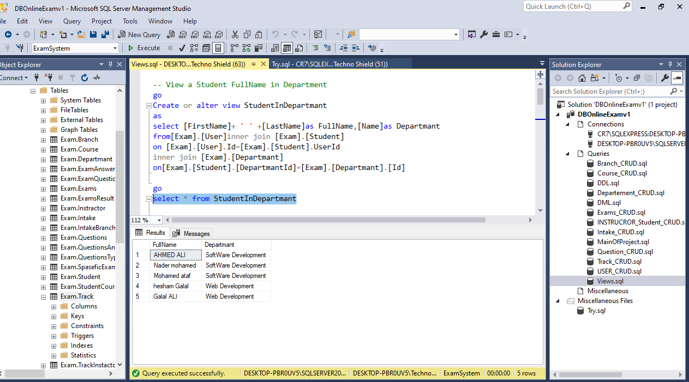

 ***Show Instractor Fullname*** ***and*** ***Department:*** 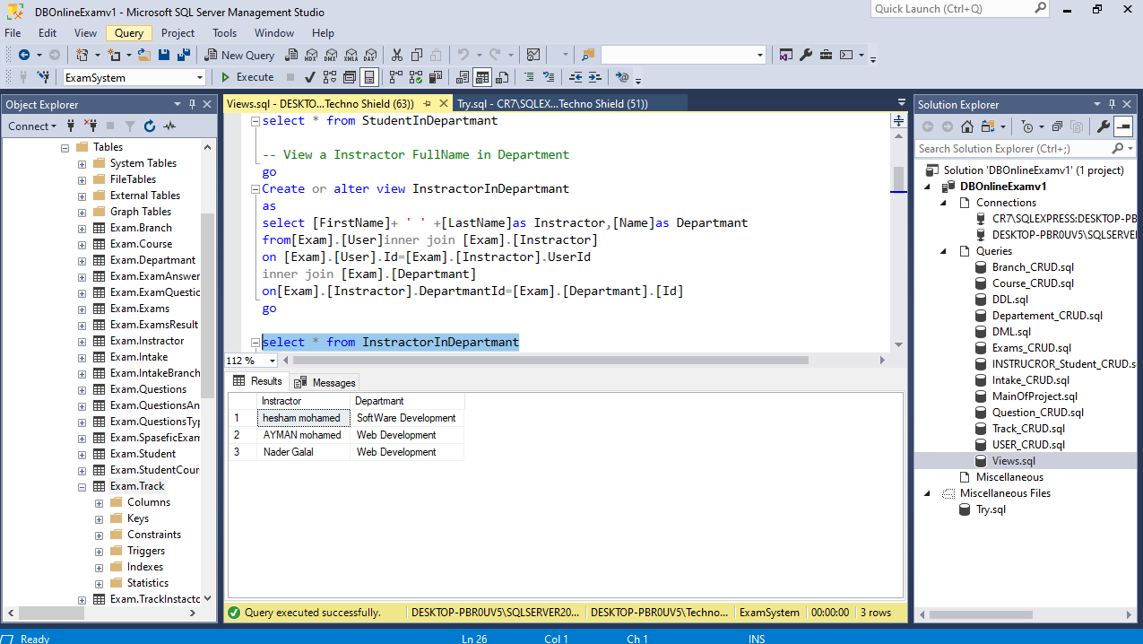

*** Show Student in Course:***

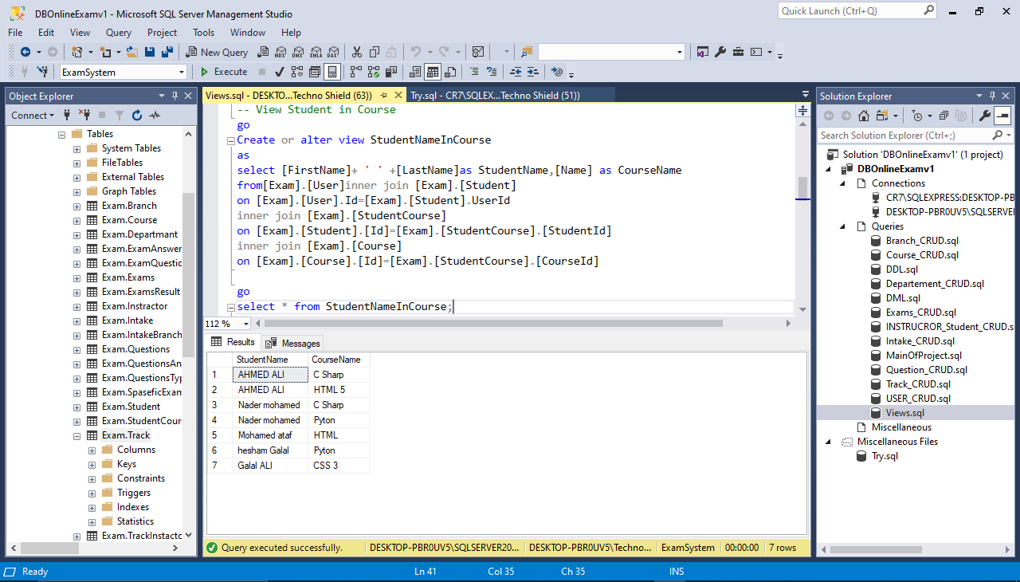

*** Show Instractor in Course:***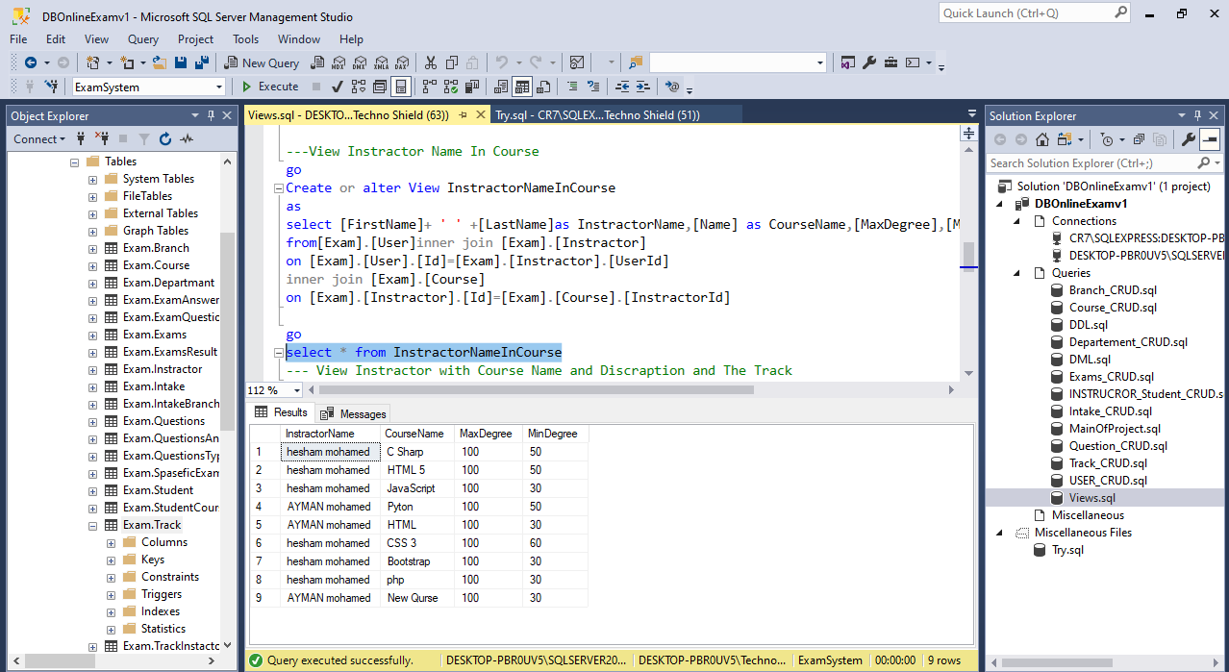

*** Show_ Instractor with Course Name and Discraption and The Track:*** 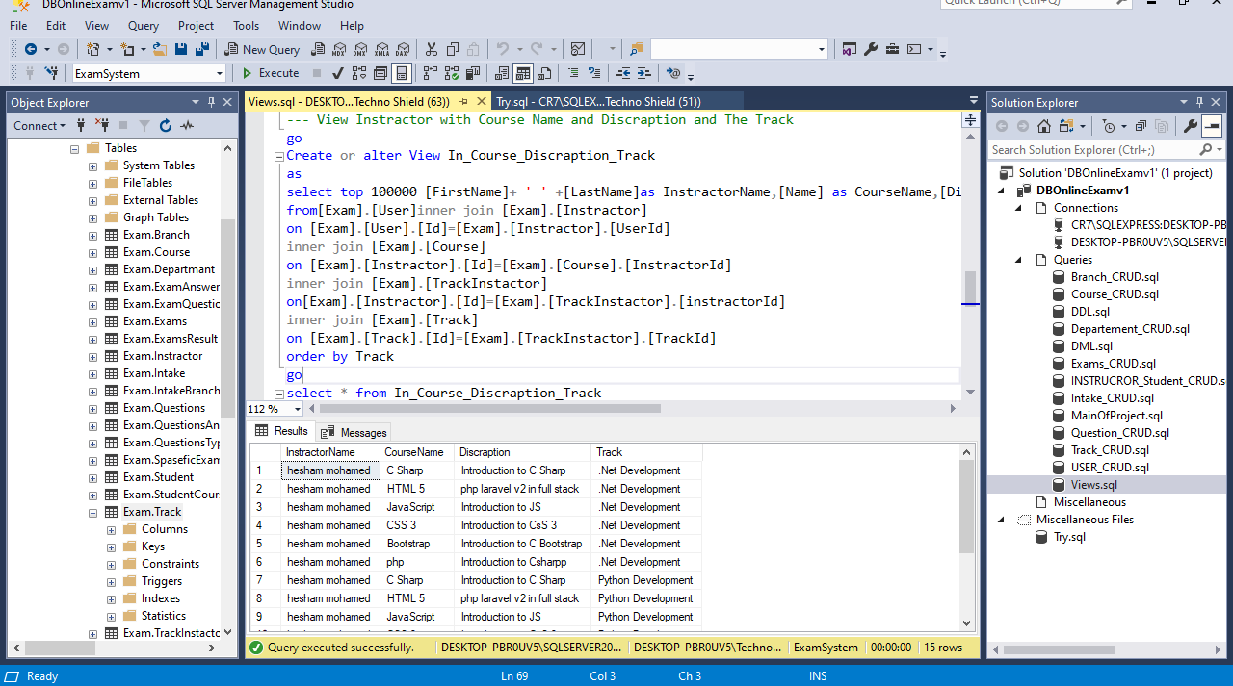

*** Show Manger Name For Instractor (Self Join):*** 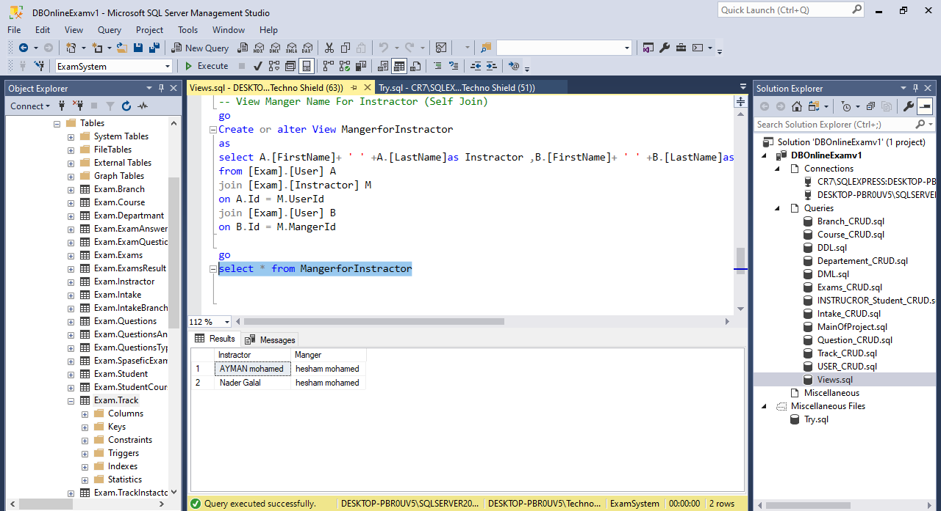

**Triggers:**

***PreventDeleteInstractor C:\Users\Lenovo\AppData\Local\Microsoft\Windows\INetCache\Content.Word\trigger6.png***

***C:\Users\Lenovo\AppData\Local\Microsoft\Windows\INetCache\Content.Word\trigger6.png***

***PreventDeleteStudent***

***C:\Users\Lenovo\AppData\Local\Microsoft\Windows\INetCache\Content.Word\trigger6.png***

***[Update_Student]***

***C:\Users\Lenovo\AppData\Local\Microsoft\Windows\INetCache\Content.Word\trigger6.png***

***[Update_Instractor]***

***C:\Users\Lenovo\AppData\Local\Microsoft\Windows\INetCache\Content.Word\trigger6.png***

**U*pdate_trak for trak table***

***C:\Users\Lenovo\AppData\Local\Microsoft\Windows\INetCache\Content.Word\trigger6.pngprevent _trak_Deletion***

***C:\Users\Lenovo\AppData\Local\Microsoft\Windows\INetCache\Content.Word\trigger6.pngupdateto department***

***C:\Users\Lenovo\AppData\Local\Microsoft\Windows\INetCache\Content.Word\trigger6.png***

***No deleted in trak(prevent_trak_deletion)***

***C:\Users\Lenovo\AppData\Local\Microsoft\Windows\INetCache\Content.Word\trigger6.png***

***No deleted in branch(prevent_trak_deletion)***

***C:\Users\Lenovo\AppData\Local\Microsoft\Windows\INetCache\Content.Word\trigger6.png***

***Can Not Delete Branch***

***C:\Users\Lenovo\AppData\Local\Microsoft\Windows\INetCache\Content.Word\trigger6.png***

***Can Not Delete Exam***

C:\Users\Techno Shield\AppData\Local\Microsoft\Windows\Clipboard\HistoryData\{DEFB8505-3A9C-4D36-9A9C-A1BA96BA2D14}\{321D3208-7E05-4FE7-A282-F43A8972E0E5}\ResourceMap\{4CA19A04-A938-461E-9841-D3F3F6D3232D}

***Can Not Delete Question***

C:\Users\Techno Shield\AppData\Local\Microsoft\Windows\Clipboard\HistoryData\{DEFB8505-3A9C-4D36-9A9C-A1BA96BA2D14}\{321D3208-7E05-4FE7-A282-F43A8972E0E5}\ResourceMap\{4CA19A04-A938-461E-9841-D3F3F6D3232D}

***Can Not Delete Student***

C:\Users\Techno Shield\AppData\Local\Microsoft\Windows\Clipboard\HistoryData\{DEFB8505-3A9C-4D36-9A9C-A1BA96BA2D14}\{321D3208-7E05-4FE7-A282-F43A8972E0E5}\ResourceMap\{4CA19A04-A938-461E-9841-D3F3F6D3232D}

***Can Not Delete Instructor***

C:\Users\Techno Shield\AppData\Local\Microsoft\Windows\Clipboard\HistoryData\{DEFB8505-3A9C-4D36-9A9C-A1BA96BA2D14}\{321D3208-7E05-4FE7-A282-F43A8972E0E5}\ResourceMap\{4CA19A04-A938-461E-9841-D3F3F6D3232D}

***Can Not Delete Track***

C:\Users\Techno Shield\AppData\Local\Microsoft\Windows\Clipboard\HistoryData\{DEFB8505-3A9C-4D36-9A9C-A1BA96BA2D14}\{321D3208-7E05-4FE7-A282-F43A8972E0E5}\ResourceMap\{4CA19A04-A938-461E-9841-D3F3F6D3232D}

***Can Not Delete Department***

C:\Users\Techno Shield\AppData\Local\Microsoft\Windows\Clipboard\HistoryData\{DEFB8505-3A9C-4D36-9A9C-A1BA96BA2D14}\{321D3208-7E05-4FE7-A282-F43A8972E0E5}\ResourceMap\{4CA19A04-A938-461E-9841-D3F3F6D3232D}

***Can Not Delete Intake***

***Simble Data***

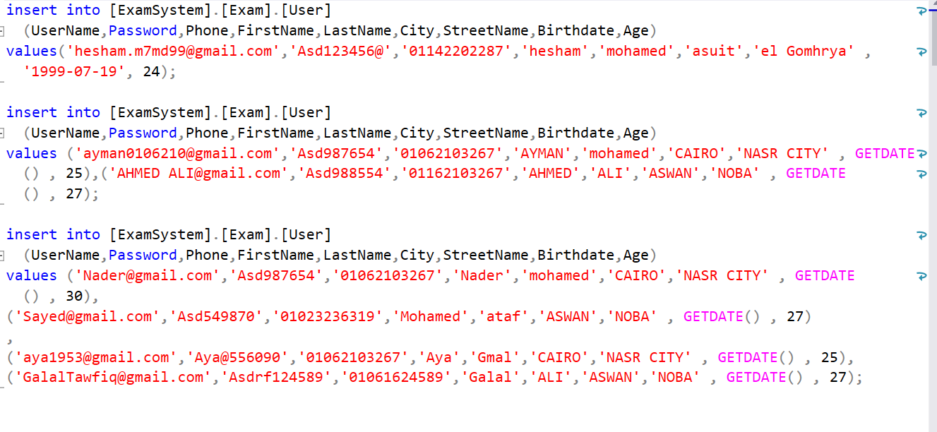

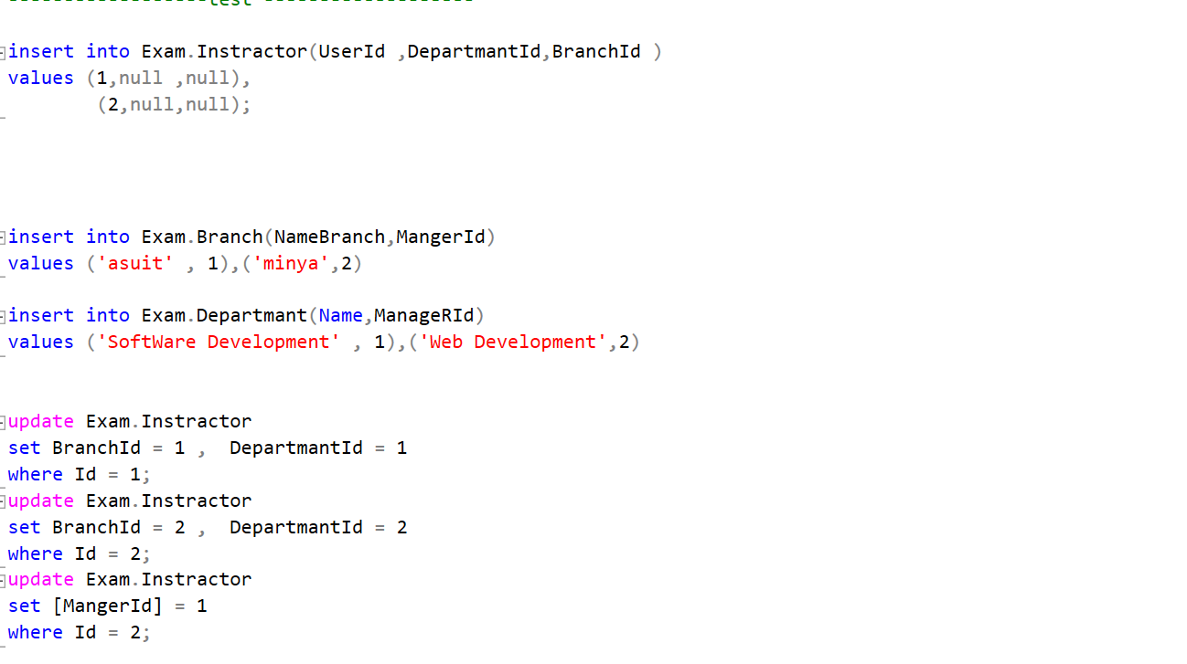

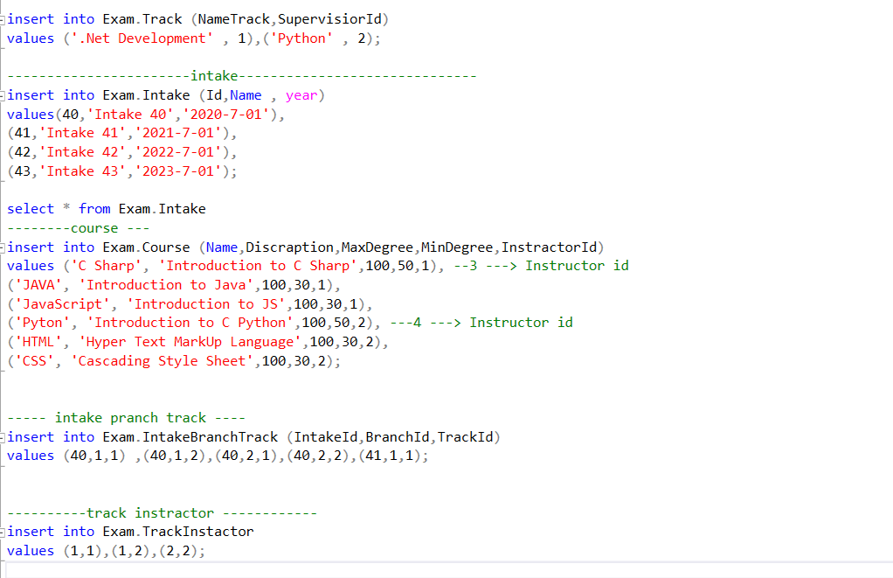

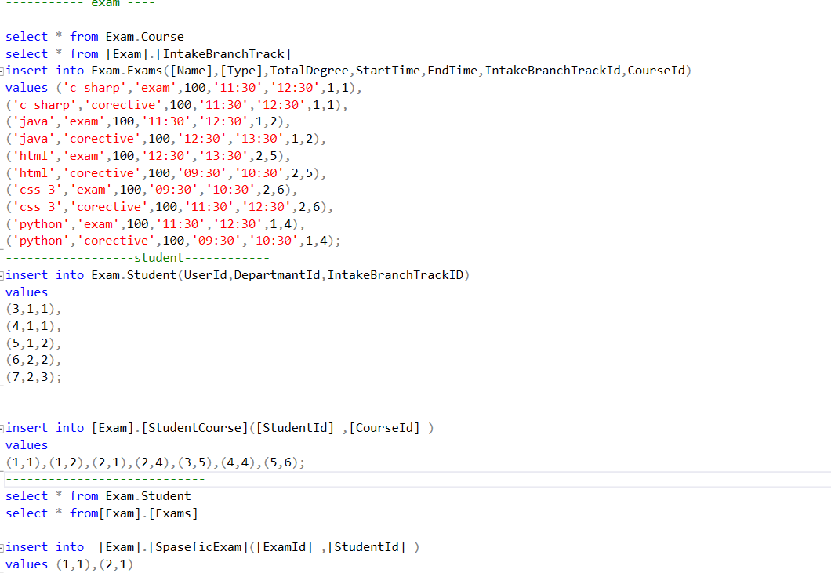

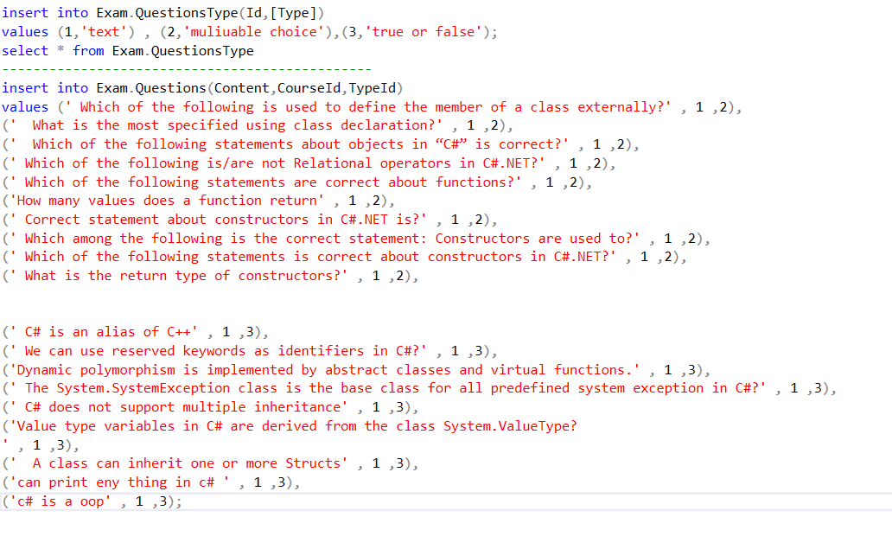

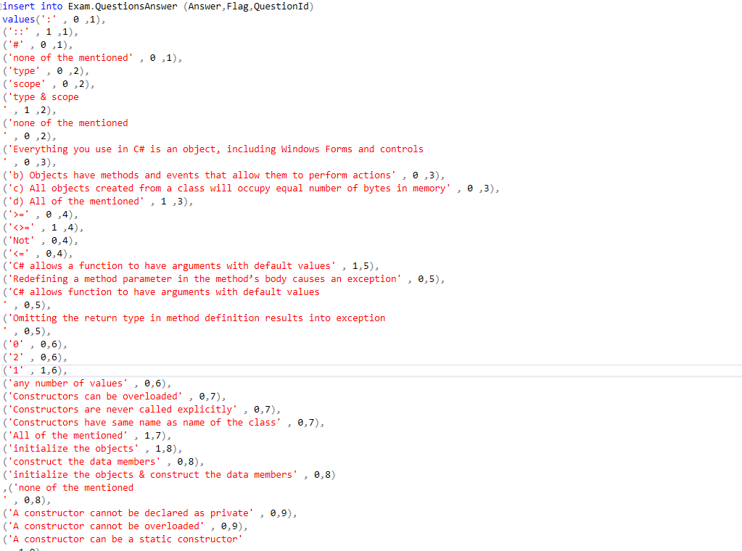

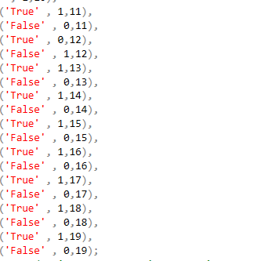

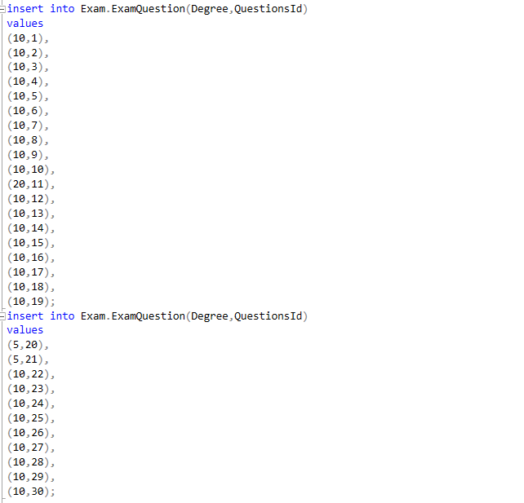

**Backup**

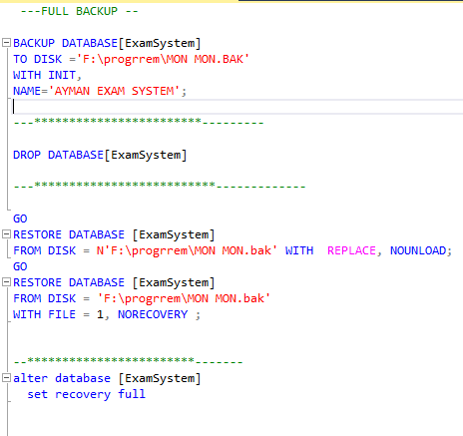

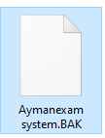

**permission**



